Siemens NX CAM UDE Settings User’s Guide

FOR

MoriSeiki NH Series

This Siemens NX CAM software covers the standard functionality that may be equipped on a MoriSeiki NH Series machine tool. This documentation covers UDE functionality for MoriSeiki NH Series machine tool. Please ignore all references to equipment your machine tool does not have.
To add new UDE to the operations, ude.cdl file should be copied to \mach\resource\user_def_event\ and overwrite the old file.

UDE – Coolant On
User may add UDE "Coolant On" as a start event to operation to output coolant code. This UDE is non-model. Which means the control mode only implemented in current operation with this UDE.
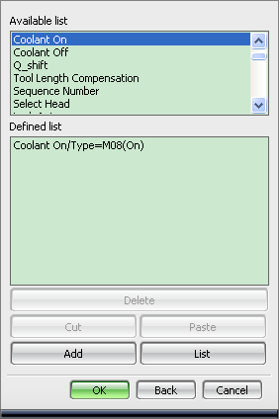
This UDE support following 10 different mode,
M8(On), M7(Oil shot), M50(Oil-hole drill), M51(Air blow), M52(Dust collector air blow), M53(Sensor air blow), M55(Oil shot 2), M80(Shower), M88(Thru), M92(Oil mist).
User can select the mode they want as the picture shows below.
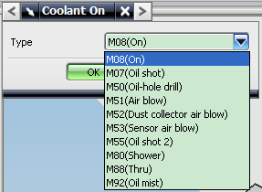

UDE – Coolant Off
User may add UDE "Coolant Off" as a end event to operation to output coolant off code. This UDE is non-model. Which means the control mode only implemented in current operation with this UDE.
This UDE can output 5 different M-code for coolant off. They are,
M09(Off, Oil), M58(Dust or Sensor Airblow), M59(Air blow), M81(Shower), M89(Thru).
In these 5 different code, M09 can cancel all the oil related coolant mode, like M07(Oil shot), M50(Oil-hole drill), M55(Oil shot 2) and M92(Oil mist).
M58 can cancel two different air blow coolant mode M52(Dust collector air blow) and M53(Sensor air blow).
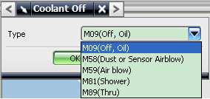

UDE – Q_shift for G76 and G87
User may add UDE "Q_shift" to a fine boring or back boring operation as a start event to output Q value which means shift amount of tool in G76 and G87. This UDE is non-model. Which means the control mode only implemented in current operation with this UDE.
User must add this UDE in the operation of G76 or G87. User should input the Q value in the dialog of Q_shift event. Then when user post the operation, Q will be output with the value input.
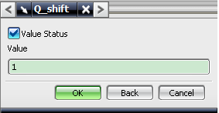
The post output will be,
G40 G80
G91 G30 Z0 M05
G30 X0 Y0
T06
M01
M06
G90 G00 G58 X24.857 Y40.114
B0
G43 Z53. H6 S1000
M03
G87 Z45. R53. Q1.0 F250
X31.803 Y34.977
G80
G91 G30 X0 Y0 Z0
G28 M05
M30

